**AML FINAL PROJECT**

**Exploring the Evolution of NLP: From RNNs and LSTMs to Transformer Models**

**SUMMARY**

The Recurrent Neural Network model (RNN) and the long short-term memory (LSTM) network where very competitive NLP models before the Transformer was introduced. These were leading examples of which every next generation of machine learning/language processing technology took a huge step. Their emergence facilitated our ability to obtain inner knowledge, and to learn foreign languages. RNNs' ability to capture sequential information made them to be more popularly adopted for applications like language translation, speech recognition, and language modeling. Using their gated nature, LSTM networks completely dispelled the problem of vanishing gradients in traditional RNNs, making it possible for longer data sequences to be trained effectively. Through this, the door was opened to countless applications of natural language processing, like machine translation and sentiment analysis.

However, RNNs and LSTMs were not entirely perfect! These models failed to process sentences and texts with relatively long content. The sequentially in data feeds means that the earlier segments of the sequence may gradually become less important and are being passed to the network along the way. For this reason, the models were not able to understand complicated textual details as well. For reference, it was like trying to put together a puzzle with missing pieces when I try to understand a complicated story by trying to understand each word individually.

In my paper, I investigated the Transformer in the NLP domain through the lens of the revolutionary concept. It scrutinizes the difficulties experienced by the earlier ones like the recurrent neural networks (RNNs) and long short-term memory (LSTM) networks as far as the sequence of long text is concerned. Through the introduction of the Transformers with new architecture and attention mechanism Transformers NLP (natural language processing) saw a major leap.

**Introduction to the Transformers:**

Transformers was a ground-breaking solution that changed NLP in response to these constraints. Transformers introduced a novel architecture that allowed models to consider the entire input sequence at once, in contrast to RNNs and LSTMs, which processed sequences sequentially. The addition of attention mechanisms allowed the model to focus on pertinent portions of the input and give different words different levels of importance, enabling parallel processing. Transformers improved upon earlier models' drawbacks and created new avenues for language generation and comprehension.

**Working of the Transformer highlighting the key findings of my:**

Another point I would like to emphasize is the fact that one of the major advantages of Transformers is that they use attention mechanisms enabling them to concentrate on the most useful fragments of the input sequence. The deployment of an attention-based mechanism helps Transformers to focus on the impactful words and the content and not ignore straightforward ones, resulting in enhanced reading and language generation abilities.

When the Transformer is reading a sentence, special words get more attention. In a nutshell, this highlights the fractures that might emerge and prevent missing critical details. These powerful words undergo an elevation, which makes the Transformer give them a special significance in the process of figuring out what the sentence implies.

**One may wonder:** What about the less important words? Well, the Transformer understands how they aren't as important so therefore it disregards them. Although they stay in the background, focusing on all of them is not the main intention. This trick has been useful to Transformers in comprehending language. One of the most useful skills of a summarizer is their ability to sift through the important and the less important parts of a

sentence and figure out what a sentence is about and come up with the text that

consistently makes sense.

The Transformer has left quite an impact on the development of NLP, but some hindrances are still present. Researchers are working on strategies for optimizing model size and decreasing computational complexity, as well as for making attention mechanisms more comprehensible. As a matter of fact, the development of Transformers does exactly what it was designed for, i.e., the creation of new models that will progress forward in the field and kick off further innovation.

**INTRODUCTION**

I would like to kick this off by emphasizing the emergence and application of Natural Language Preprocessing and further explain its relevance to my report or to deep learning in general! NLP is impressive because it allows a machine to understand language the most basic form of human interaction between humans and between humans and machines. Over the past decade, Natural Language Processing has revolutionized our daily life. It powered virtual assistants such as Siri and Alexa and provided real-time language translation services. It has revolutionized customer service with chatbot solutions that can help us to understand and field customer inquiries. It changed the way I look for news with more reliable search results. NLP has also made significant advancements in healthcare, finance, and education, thus helping in easily understanding complex volumes of data as well as assisting in optimal decision making.

**The ultimate problem in question:**

* Artificial intelligence has long relied on Natural Language Processing (NLP), which allows machines to comprehend and produce human language. However, as mentioned previously, processing lengthy text sequences has proven to be extremely difficult for traditional NLP models, like recurrent neural networks (RNNs) and long short-term memory (LSTM) networks. As a result, these models are less useful for tasks like machine translation, text summarization, and question answering.
* Throughout the training, gradients are moving backward through networks and getting smaller and smaller in magnitude. RNNs and LSTMs have such a feature like it is. Hence, learning long-term dependencies becomes a difficult task as the model might experience problems updating the parameters that associate the words which are located far in the sequence.

* Unlike traditional NLP models, which analyze text in a sequential manner, they can only deal with one word at a time when they are looking at text. The model is capable of dealing with sentences in parallel, but it spends considerable amount of time on training and inference especially on lengthy text sequence. This might be the reason why these types of models can’t cope with large datasets or real-time applications where speed of processing is the critical factor.

Resolving difficulties arising while processing with long sequences of text is very important to addition of capabilities of Natural Language Processing (NLP) models. These problems impair the operation of the common NLP models including long short-term memory (LSTM) networks and recurrent neural networks (RNNs), especially in the language generation and understanding tasks that require comprehending long text sections.

**The task of NLP processing long text sequences is considered a major challenge influencing many areas, and I focus on this problem primarily throughout the report**

# **CURRENT RESEARCH**

Over the past decade, the field of Natural Language Processing (NLP) has experienced rapid advancements due to the evolution of deep learning models. Early models such as Recurrent Neural Networks (RNNs) and Long Short-Term Memory (LSTM) networks marked important milestones by enabling machines to process sequential data effectively. However, these models presented notable challenges, particularly when dealing with long-range dependencies and lengthy text sequences.

**Evolution of Models**

**>Recurrent Neural Networks (RNNs):**

RNNs introduced the idea of sequence modeling, allowing models to process data where previous outputs influence future predictions. They were particularly useful for tasks such as speech recognition and machine translation. However, RNNs struggled with the ***vanishing gradient problem***, making it difficult for them to retain information over long sequences.

**>Long Short-Term Memory Networks (LSTMs):**

LSTMs addressed some of the RNNs' limitations by introducing gated mechanisms to better manage long-term dependencies. Their architecture allowed networks to selectively remember or forget information, leading to improvements in tasks such as text generation and sentiment analysis. Despite this, LSTMs still faced challenges when processing extremely long documents and suffered from ***sequential computation bottlenecks***, limiting training speed.

**Introduction of the Transformer Model**

The introduction of the ***Transformer model*** by Vaswani et al. (2017) marked a revolutionary shift in NLP. Transformers abandoned the sequential nature of RNNs and LSTMs by adopting a ***self-attention mechanism***. This allowed the model to focus on relevant parts of the input sequence simultaneously, enabling ***parallel processing*** and significantly improving both training efficiency and performance on long text sequences.

Key components of the Transformer architecture include:

* **Multi-Head Self-Attention**: Enables the model to attend to information from different representation subspaces at different positions.
* **Positional Encoding**: Injects information about the relative or absolute position of tokens in the sequence, compensating for the loss of sequential order.
* **Feed-Forward Networks**: Applies additional transformations to improve model capacity.

**Emergence of Pretrained Models: BERT and Beyond**

Following the success of the Transformer, models such as **BERT (Bidirectional Encoder Representations from Transformers)** further advanced the field. BERT introduced **bidirectional training** of transformers, meaning the model could consider context from both the left and the right of a token, leading to significant improvements in a variety of NLP tasks, including question answering, named entity recognition, and text summarization.

Subsequent models like **GPT (Generative Pretrained Transformer)** and **T5 (Text-To-Text Transfer Transformer)** built upon this foundation, demonstrating the scalability of Transformers across both language understanding and generation tasks.

**Effectiveness of Transformer-Based Models**

* **Performance**: Transformers have achieved **state-of-the-art results** across numerous NLP benchmarks.
* **Flexibility**: They are highly adaptable to various tasks with minimal changes in architecture (e.g., translation, summarization, text classification).
* **Scalability**: Transformers scale well with increased data and computational resources, improving accuracy with model size (e.g., GPT-3, PaLM).

**Challenges and Limitations**

Despite their success, Transformer-based models are not without challenges:

* **Computational Cost**: Training and deploying large Transformer models require enormous computational resources, making them less accessible for smaller organizations.
* **Data Hunger**: These models typically need vast amounts of labeled data for pretraining and fine-tuning.
* **Interpretability**: Understanding how and why a Transformer model makes specific decisions remains a difficult task, raising concerns in critical applications like healthcare and legal domains.
* **Bias and Fairness**: Transformers trained on internet-scale datasets can inherit and amplify societal biases present in the training data.

**Key findings and explanation of Transformer Models**

**A Foundation for Later Innovations:** Through my study I can reveal that the

Transformer itself accounts for the development of practical models such as BERT, GPT, and T5. These models are based on the transformation of natural language, and they are the foundation of many NLP applications like text generation and translation.

**The Power of Attention:** Specifically, the way these types of models with the built-in power of attention have changed AI capabilities is actually incredible. The updated model now seems to generate more coherent and contextually relevant content by applying the attention mechanism. Thus, the progress permitted the development of more reliable search engines, language translators with more accuracy, and chatbots that can even carry on a lengthy conversation.

**Democratization of Artificial Intelligence:** I realized from my analysis that the AI becomes more and more of an ordinary thing. Pre-trained models, originating from the Transformer architecture, are getting more and more widespread. This gives an opportunity for those, who have poor resources at their disposal to possess cutting edge AI things. This implies that beyond just the big businesses or the academic institutions is the many individuals and organizations who can now take advantage of the benefits AI technology as advanced could offer.

**Explanation of Transformer Model Architecture**

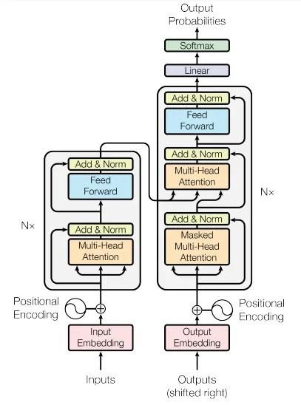

The above is the architecture of a Transformer model, as picked out from an article by Dr. Ernesto Lee summarizing the findings of Vaswani’s extraordinary research. I referred to this article to better understand my topic of interest. This model serves as a foundation for advanced language models like GPT (Generative Pre-trained Transformer) and BERT (Bidirectional Encoder Representations from Transformers).

**Input Layer:** This is where I kick it off. Suppose, let us say I put a sentence in the model to feed. Every word of the sentence stands for the vector, it is some numerical representation which the machine can understand. The vectors go through something called "input embedding", which can be considered a procedure of setting a certain identity to a particular word in the model.

**Positional Encoding:** This is important since the system has to know how the words should be placed in an order in a sentence. Positional encoding is a form of adding information about the place of each word in the sentence. This helps the model to understand that words follow a sequence.

**Multi-Head Attention:** At this point the model attempts to process various words of the input sentence together to better understand the internal connections between them.

**Add and Norm**: Moreover, the model inputs some information to the input, and it normalizes it. These actions keep the model stable and avoid any imbalance during processing.

**Feed Forward**: In the following, the data is being sent through a feedforward neural network which enables the model to capture even more complicated patterns in the data.

**Output Layer:** After the pipe is completed, the data proceeds to the output embedding box as seen from the diagram, which is very similar to input embedding, only that it is for output signals.

**Masked Multi-Head Attention:** This is almost the same as Multi-Head Attention, but here the model is not allowed to look into the sequence ahead during learning, forcing it to learn prediction one word at a time.

**Output Probabilities**: Finally, through a linear layer and a SoftMax function, the data is put up to give the probability of each word in the predicted sequence.

In simpler terms, the Transformer model processes the input text through various blocks that work using attention, feed forward layers to understand and then generate language obtaining a meaning and preserving the context of the text.

**INDUSTRY APPLICATIONS OF DEEP LEARNING**

Deep learning has revolutionized numerous industries by enabling machines to learn complex patterns from massive datasets, often outperforming traditional machine learning methods. Here, I focus on its transformative impact on **healthcare**, **transportation**, and **security.**

## **Healthcare**

Deep learning has significantly advanced the healthcare industry by improving diagnostic accuracy, treatment personalization, and patient care efficiency:

* **Medical Imaging and Diagnostics**: Convolutional Neural Networks (CNNs) are extensively used for detecting anomalies in X-rays, MRIs, CT scans, and mammograms. For example, deep learning models can detect cancers, tumors, and fractures with accuracy comparable to, or sometimes better than, experienced radiologists.
* **Predictive Analytics**: Deep learning models predict disease progression (e.g., diabetes, Alzheimer's) by analyzing electronic health records (EHRs).
* **Drug Discovery**: Models like DeepMind's AlphaFold have revolutionized protein structure prediction, accelerating drug development timelines.
* **Virtual Health Assistants**: NLP-powered chatbots and virtual assistants help patients schedule appointments, monitor symptoms, and access medical information.

## **Transportation**

Deep learning plays a crucial role in modernizing transportation systems, particularly with autonomous vehicles and smart city initiatives:

* **Autonomous Driving**: Self-driving cars rely on deep learning models for real-time object detection (pedestrians, vehicles, traffic signals), path planning, and decision-making. Technologies from companies like Tesla, Waymo, and NVIDIA use deep neural networks to enable safer driving.
* **Traffic Prediction and Management**: Deep learning algorithms analyze traffic data to predict congestion and optimize traffic light scheduling, reducing delays and emissions.
* **Driver Monitoring Systems**: AI models monitor driver behavior, detecting signs of drowsiness or distraction to prevent accidents.

## **Security**

Security has been significantly enhanced with deep learning applications that enable intelligent monitoring, threat detection, and rapid response:

* **Facial Recognition**: Deep learning models recognize faces in real-time, assisting in surveillance, border control, and secure authentication systems (e.g., smartphone unlocking, airport security).
* **Anomaly Detection**: In cybersecurity, deep learning models detect unusual patterns indicative of hacking attempts, malware infiltration, or insider threats.
* **Video Surveillance**: Object tracking and behavior recognition algorithms automatically detect suspicious activities in crowded environments, such as airports, stadiums, and public transport systems.

# **ANALYSIS**

During research, I came across NLP’s (Natural Language Processing) next big change with The Transformer. Transformers have made way for significant opportunities for language generation and comprehension through reduction of the negative effects of previous models such as Recurrent Neural Networks (RNNs) and long short-term memory (LSTM) networks.

Turning attention mechanisms of Transformer is a drastic factor. Such techniques, which allow the model to focus on the important elements of the input text, make the model capable of handling long text sequences more efficiently. On the other hand, performance of a plethora of NLP tasks will be greatly improved like question answering, text summarization, and machine translation.

Another significant discovery that occurred due to the democratization of AI through pretrained Transformer models is this. Through these models, AI technologies are being integrated into different industries’ operations at a faster pace and innovation is being stimulated by providing access to advanced AI capabilities to a wider audience of developers and businesspeople.

In fact, my research suggests that Transformers are a major innovation in the field of natural language processing (NLP), they complete many tasks which earlier models couldn’t do, and they open the path to new improvements.

# **CONCLUSION**

Indeed, the introduction of Transformer architecture has triggered a profound paradigm shift in natural language processing (NLP). They have come up with new ideas and helpful gadgets that cover LSTM networks and RNNs to the limit. Transformers are particularly good at handling lengthy text paragraphs and the variety of NLP tasks which they can perform with ease.

I was wowed by the functioning of the transformer-based models like BERT, GPT, or

T5. They are powering various applications that go across different industries acting like Superheroes who can power language generation and understanding. However, even more astonishing is the fact that pre-trained Transformer models allow them to utilize this technology.

Briefly, The Transformer is the one which facilitated revolution in NLP. This has brought about new types of smarter chatbots and search engine capabilities, as well as language translation software which have created plenty of opportunities. That is just the beginning! AI-driven applications have a bright future ahead, with Transformers' leading the way.

Relevant Links: <https://datagen.tech/guides/computer-vision/transformer-architecture/>[https://quantpedia.com/bert-model-bidirectional-encoder-representationsfromtransformers/](https://quantpedia.com/bert-model-bidirectional-encoder-representations-from-transformers/)

[https://drlee.io/an-intuitive-explanation-of-attention-is-all-you-need-the-paper-](https://drlee.io/an-intuitive-explanation-of-attention-is-all-you-need-the-paper-that-revolutionized-ai-and-39aac5827411)

[thatrevolutionized-ai-and-39aac5827411](https://drlee.io/an-intuitive-explanation-of-attention-is-all-you-need-the-paper-that-revolutionized-ai-and-39aac5827411)

<https://hub.packtpub.com/paper-in-two-minutes-attention-is-all-you-need/>

<https://viso.ai/deep-learning/attention-mechanisms/><https://www.turing.com/kb/recurrent-neural-networks-and-lstm>

Bibliography:

Vaswani, A., et al. (2017). "Attention is All You Need." In Advances in Neural Information Processing Systems.

Devlin, J., et al. (2018). "BERT: Bidirectional Encoder Representations from Transformers." In Proceedings of the 2019 Conference of the North American Chapter of the Association for Computational Linguistics: Human Language Technologies.

**EXAMPLE CODE:**

This imports the NumPy package, which is used for numerical operations (such arrays and mathematical computations). In this scenario, it is useful for conducting element-wise multiplication.

The class Simple Transformer Example replicates a basic model processing example.

The constructor (__init__): The class is initialized given a parameter model, which is saved as an instance variable self. Model. This is a placeholder for a real model, which may be a machine learning model or another object in practice.

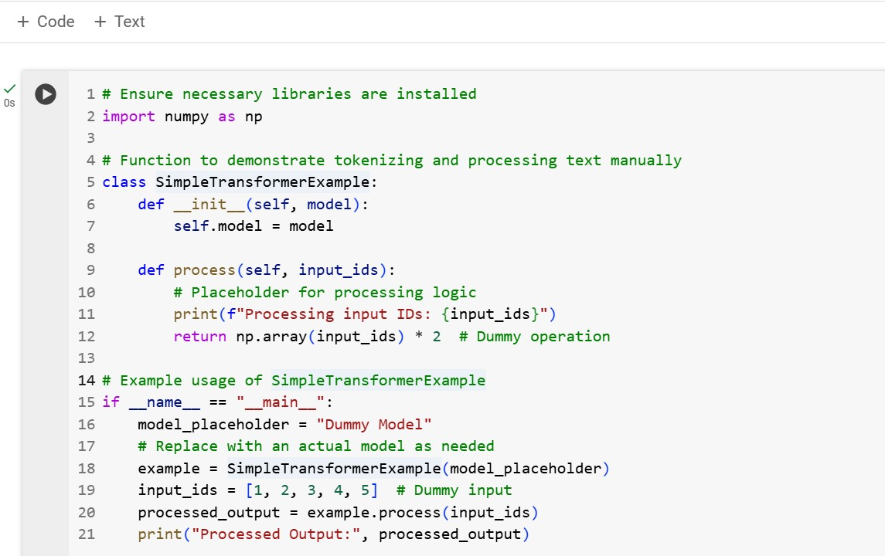

This method handles the input data (input_ids).

The print statement outputs the input data to the console (for demonstration purposes).

Dummy Operation: It creates a NumPy array from the input list input_ids and multiplies each element by two (a placeholder operation). In a real-world model, this step would involve actual data processing.

Check for direct execution. The if __name__ == "__main__" statement ensures that this code occurs only when the script is executed directly (rather than being imported as a module).

Creating the Class Instance: model placeholder = "Dummy Model" represents

a dummy model. This placeholder initiates the creation of a Simple Transformer Example instance.

Processing Data: A sample list [1, 2, 3, 4, 5] is supplied to the process method, which runs the dummy operation and provides the result. Print Output: The processed output is printed.

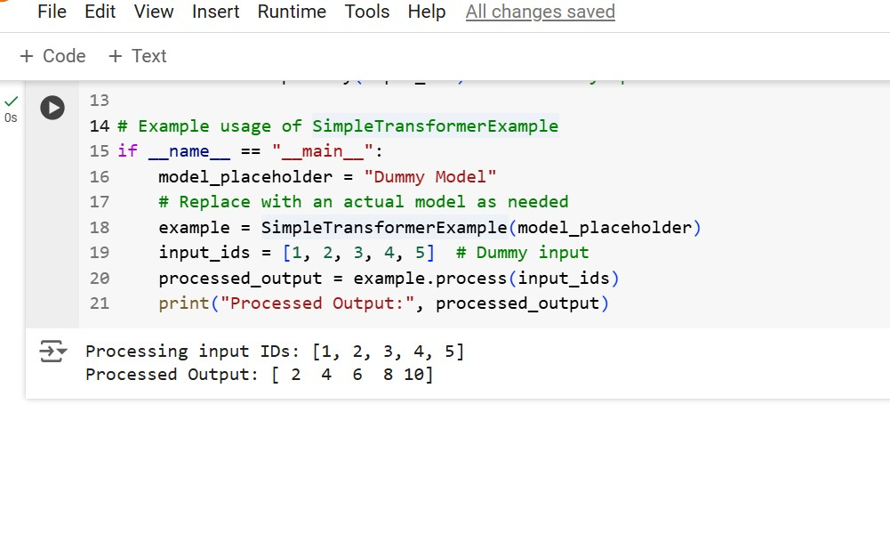

CONCLUSION:

The program outputs both the input ([1, 2, 3, 4, 5]) and the processed output ([2, 4, 6, 8, 10]), which is the result of multiplying each member in the input list by two.

This code exhibits a basic object-oriented structure in which a class (Simple Transformer Example) replicates the processing of input data using a model. The class consists of two main parts:

The model parameter is a placeholder (in this case, a string) that can be changed with a real machine learning model (for example, a neural network or transformer).

Processing: The process method accepts input data (input_ids), executes a dummy operation (multiplication by 2), and returns the result. In the actual world, this strategy would use more complex transformations, such as running data through a model, to make predictions.

The main block generates a class instance with a model placeholder, processes sample input, and prints the results. In fact, this structure can be extended to combine actual models and perform data preprocessing and handle more complex tasks like prediction or classification.